Project Proposal on

Break the Wall

Roshan Raj Thapaliya

NCC ID: 00163095

Computing Project

Level 5 Diploma in Computing

Softwarica College of IT & E-Commerce

Kathmandu, Nepal

April 9, 2017

Contents

Introduction 3

1.1 Aims 3

1.2 Objectives 4

1.3 Main features 4

1.4 Development methods 4

Project plan 5

2.1 Work Breakdown Structure (WBS) and Time Estimate 5

2.2 Milestones 7

2.3 Schedule 7

Risk Management 9

Configuration Management 10

Conclusion 11

References 12

Chapter 1

# Introduction

With the growth of computer and electronic devices, different games have been developed to entertain and give knowledge peoples. Different types of games help player to develop various skills like thinking power, passion and creative work.

Break the Wall is Platform game which involves an avatar to jump over obstacles to advance the game. The player must control the jumps to avoid the avatar fall from platform or from hitting the unnecessary objects. The player must sign up to play game. The game record every score gain by the player. It also displays highest score compared with players own score recorded in database.

This game helps to entertain players. Players will get certain amounts of life in the game. If the player life finished then there will be game over. Players also can increase life by collecting lives while playing game. After completing one level players can enter another level. Player must collect coins to gain extra scores.

## 1.1 Aims

The main aims of this project are as follow:

* To build Platform based desktop game.
* To provide entertainment for player.
* To provide user friendly interface with good graphics.
* To store detail about player and record all score.

## 1.2 Objectives

The objectives of this project are given below:

* To gather and analyze the requirement for developing system.
* To design and develop database for storing the data.
* To design the system according to requirement.
* To develop the system with fulfilling all the requirement.
* To test the system against the requirement through various test cases.
* To document all the system development phases for future reference.

## 1.3 Main features

The main features of the game are listed below:

* 2d platform based game
* More than eight levels in game
* Store players details and score
* Display highest score while playing game
* Exciting and interesting levels to complete

## 1.4 Development methods

There are various types of software development methods. Object Oriented Methodology, Agile, Waterfall Methodology are some examples of development methods. I will be using waterfall Methodology for development methods.

The waterfall model is a popular version of the systems development life cycle model. Waterfall model describes a development methods that is rigid and linear. This method has distinct goals for each phase of development. Each phase must be completed sequentially to jump in to next phase.

Following are the sequential phase involved in waterfall method:

1. Analysis and Requirement Specification
2. System Design
3. Implementation
4. Testing
5. Deployment of system
6. Maintenance

The main reasons for using waterfall method in this project are as follow:

* Waterfall model is simple and easy to understand and use.
* All phases are processed and completed one at a time.
* It is easy to measure progress by referring to objectives defined for each phase.
* It guarantees systematic planning and scheduling.
* It ensures all procedures associated with each step are undertaken.  (istqbexamcertification, 2016)

Chapter 2

# Project plan

Technologies used:

Following programming language, tools, development environment and platforms are used for developing this system:

* Programming language: JAVA

Java is a programming language and computing platform first released by Sun Microsystems in 1995. Currently it is own by Oracle Corporation. It is high level and object oriented programming language. It is also machine or platform independent.

* Database: MySQL

MySQL is the popular open source relational database management system based in Structured Query Language. It is reliable, efficient and fast. It runs on virtually all platforms; hence it can be used in a wide range of applications. (techtarget, 2014)

* Integrated Development Environment: NetBeans

NetBeans is open source java based integrated development environment which is designed to write down and compile codes. It helps to reduce error in coding. (theserverside, 2014)

* Platform: Desktop based Java application

## 2.1 Work Breakdown Structure (WBS) and Time Estimate

Work breakdown system is used to manage and organize various tasks into various sections. It helps to portray tasks relationship with other tasks. Tasks are divided into various sections which helps to develop project efficient and according to time. Since we are using waterfall model as development model, the requirement and time of the project is fixed. This system helps to track all the tasks with time. It helps to manage and allocate resources, monitoring and controlling project. It also helps to ensure that the project is being directed according to plan without missing tasks. (techtarget, 2015)

Fig: Work Breakdown System (WBS)

## 2.2 Milestones

Milestone is a specific point in time within a project lifecycle used to measure the progress of a project toward its goal. Milestones are used as signal posts for project start and end date, external review and submission of a major deliverable. It is a reference point that marks a major event in a project. (wrike, 2013) Given table shows some of the milestones of the project:

|  |  |  |
| --- | --- | --- |
| S.N. | Milestones | Date |
| 1. | Project Proposal | April 9, 2017 |
| 2. | Analysis Specification | April 23, 2017 |
| 3. | Design Specification | May 24, 2017 |
| 4. | Implementation | June 14, 2017 |
| 5. | Final Project Submission | July 11, 2017 |
| 6. | Final Presentation | July 16,2017 |

## 2.3 Schedule

Schedule is a timetable that outlines start and end dates and milestones that must be met for the project to be completed on time. It is necessary to schedule activities for successful development of a system. Every activity is scheduled at one time and when one activity is completed another activity is start working.

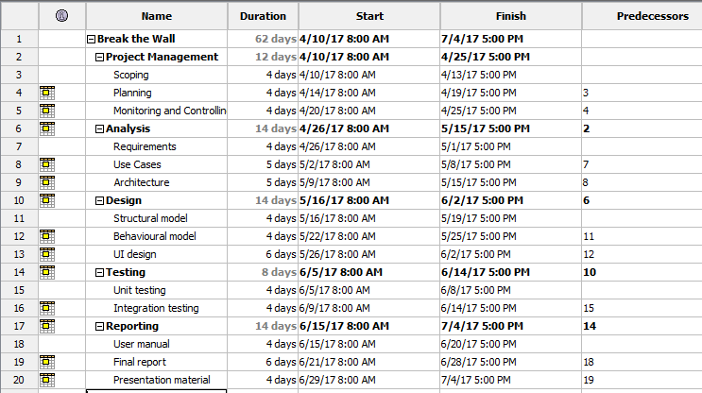

Figure: Spreadsheet of the project

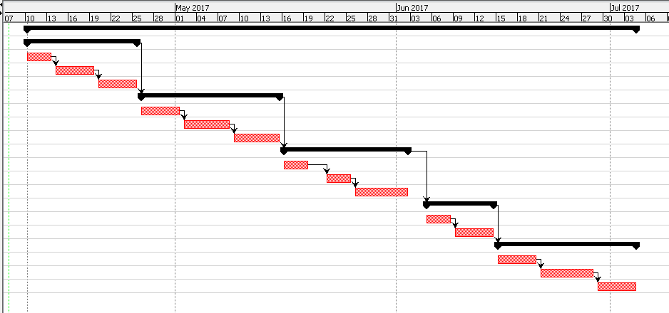

Figure: Gantt Chart

Chapter 3

# Risk Management

Risk management is the process to identify, analyze and treat loss exposures and monitor risk control. Any ricks are unpredictable in project which can bring negatively impact on project timetable. Risk can be control or prevent with the help of risk management. Impact of risk can be estimate using following formula.  (wrike, 2014)

Impact = Likelihood x Consequence

Following table show the risk likelihood values:

|  |  |
| --- | --- |
| Likelihood | Value |
| Low | 1 |
| Medium | 2 |
| High | 3 |

In the above table, likelihood is scaled from 1 to 3 i.e., 1 being low and 2 being high.

Following table show the risk consequence values:

|  |  |
| --- | --- |
| Consequence | Value |
| Very low | 1 |
| Low | 2 |
| Medium | 3 |
| High | 4 |
| Very high | 5 |

In the above table, consequence is scaled from 1 to 5 i.e., 1 being very low and 3 being very high.

|  |  |  |  |  |  |
| --- | --- | --- | --- | --- | --- |
| S.N. | Risk | Likelihood | Consequences | Impact | Action |
| 1 | Lack of resources | 2 | 3 | 6 | All the necessary resources should be managed at the beginning of project |
| 2 | Hard disk crash | 1 | 5 | 5 | Every required data must be backup daily or weekly |
| 3 | Failure to meet requirement | 2 | 5 | 10 | Planning should be done carefully at every stage |
| 4 | Failure of software or crash | 1 | 4 | 4 | Software should be regularly update. |
| 5 | Bad estimation | 2 | 5 | 10 | Proper time allocation should be done from the beginning |
| 6 | Data loss | 2 | 3 | 3 | High data security should be implemented |

Chapter 4

# Configuration Management

The configuration management process identifies and tracks the all configuration items throughout the operational life. (techtarget, 2014)

It is used to control different versions of the system that are develop. This help to rollback to earlier version if necessary. All the files, documents and reports are maintained using appropriate folder structure. All necessary data are kept in folder name ‘Backup’. From backup, it helps to gain older version of system if necessary. Changes can be track down and stored in design folder. All the coding part are stored in GitHub. It helps to prevent data loss. Related files are stored in related folders. This structural folder system keeps all the tracks and changes that occurs through the project. Following figure show directory structure of different folders and files for our system.

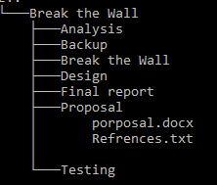

Figure: Configuration management

Chapter 5

# Conclusion

At last, the project will be developed to entertain the players. Players must control the avatar and complete certain missions or level. Players should sign up to play the game. The project is developed using waterfall model for development model. Java is used as programming language (front end), MySQL as database (back end) and NetBeans as IDE. The project plan is done via work breakdown system and necessary time schedule is planned with Gantt chart. Major milestones are setup with dates. It helps to maintain and manage different task in the project. Some risks which can be occur during the project runtime are studies with their impacts and solution. This can help to overcome the risk that are faced during project development. Configuration management is done to keep track all the files and version control. It can provide aid to keep various version and if necessary older version can be used. The project will be developed within the given time frame with fulfilling all the requirement.

# References

istqbexamcertification, 2016. *waterfall.* [Online]   
Available at: http://istqbexamcertification.com/what-is-waterfall-model-advantages-disadvantages-and-when-to-use-it/  
[Accessed 6 4 2017].

techtarget, 2014. *What is configuration management (CM).* [Online]   
Available at: http://searchitoperations.techtarget.com/definition/configuration-management-CM  
[Accessed 8 4 2017].

techtarget, 2014. *What is MySQL.* [Online]   
Available at: http://searchenterpriselinux.techtarget.com/definition/MySQL  
[Accessed 5 4 2017].

techtarget, 2015. *What is work breakdown structure (WBS).* [Online]   
Available at: http://searchsoftwarequality.techtarget.com/definition/work-breakdown-structure  
[Accessed 6 4 2017].

theserverside, 2014. *What is NetBeans.* [Online]   
Available at: http://www.theserverside.com/definition/NetBeans  
[Accessed 5 4 2017].

wrike, 2013. *What is a Milestone in Project Management.* [Online]   
Available at: https://www.wrike.com/project-management-guide/faq/what-is-a-milestone-in-project-management/  
[Accessed 7 4 2017].

wrike, 2014. *What is Risk Management in Project Management.* [Online]   
Available at: https://www.wrike.com/project-management-guide/faq/what-is-risk-management-in-project-management/  
[Accessed 8 4 2017].